Critical Review on ___________
Article Title, Left Align, 15 pt, Times New Roman (TNR), Max. 20 Words

Author^{1,a}, Author^{2,b}, Author^{1,*}, Max. 5 authors, TNR, 12 pt.
¹ Department, Faculty, University, Address, City, Zip Code, Country
² Department, Faculty, University, Address, City, Zip Code, Country
ªE-mail address of the first author
^{b}E-mail address of the second author
*Corresponding author: e-mail

ABSTRACT
Abstract should be written in one paragraph not more than 250 words. Abstract should be written in English. The abstract should be informative and state briefly the aim of the critical review, issue, major conclusions and suggestion/recommendation. Also, non-standard or uncommon abbreviations should be avoided, but if essential they must be defined at their first mention in the abstract itself. TNR, 11 pt, single line spacing, no before after spacing.
Key words: TNR 11 pt, italic, max 7 word, and sorted A to Z

Abbreviation (if any): Please write all important abbreviations and must be defined at their first mention there. Ensure consistency of abbreviations throughout the article

1. Introduction (TNR 12 pt, Bold)
Full article max. 8000 words or 15 pages. State the objectives of the work and provide an adequate background. Please add relevant citation as follow Sibero et al. (2019) for more than 3 authors; Sibero (2020) for single authorship; Sibero and Siswanto (2020) for two authors. TNR 12 pt, single space, no before-after spacing.

2. Critical Review (TNR 12 pt, Bold, single spacing)
2.1 Sub point of critical review (TNR 12 pt, italic, capital only applied in the first word)
In this part, author should explain the main idea of the critical review. Please add relevant citation, Table or Figure. TNR 12 pt, single spacing without before-after spacing.

2.2 Tables and Figures
The title of a picture is written down below the picture, while the title of a table is written above the table. In Table, bold is applied to emphasize the table number and field names. While in Figure, bold is only applied to state the figure number. TNR 12 pt, single spacing without before-after spacing. Source of the data is written below the figure and table with TNR 10 pt. The calculation formula must be written using Equation menu in Ms. Word.

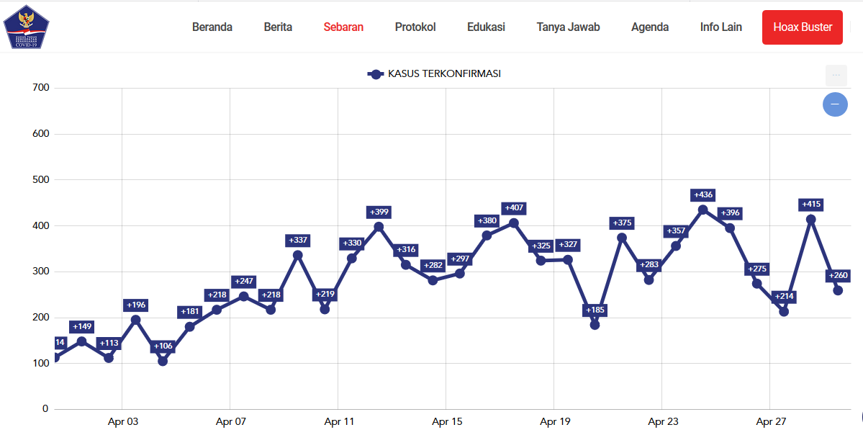
Figure 1. Data of COVID-19 positive cases per-day in Indonesia
(Source: Gugus Tugas Percepatan Penanganan COVID-19, 2020)

Table 1. Table title, TNR 12 pt
Point 1ª | Point 2^{b}
12345 ± 0.01 | 12345 ± 0.01
12345 ± 0.01 | 12345 ± 0.01
12345 ± 0.01 | 12345 ± 0.01
12345 ± 0.01 | 12345 ± 0.01
(Superscript indicates:________. ªSource:_________, ^{b}Source:______.....)

$$A=\frac{a}{b}r^{2}$$

Formula 1. Calculation of …..
(Source: ______)
Information :
A: _____
a: _____
b: _____
r: _____

3. Recommendation
State the recommendation from authors regarding the problems that has been explained in the previous chapter. Recommendation should be clearly stated. This will be the most important part in your article. Recommendation is written in paragraph.
4. Conflict of interest
Authors must state there is no conflict of interest.

5. Acknowledgments
Please expressed in a brief; all sources of institutional, private and corporate financial support for the work must be fully acknowledged, and any potential conflicts of interest are noted.

6. References
Article
Sibero MT, Igarashi Y, Radjasa OK, Sabdono A, Trianto A, Zilda DS, Wijaya YJ. 2019. Sponge-associated fungi from a mangrove habitat in Indonesia: species composition, antimicrobial activity, enzyme screening and bioactive profiling. International Aquatic Research 11: 173-186. DOI: https://doi.org/10.1007/s40071-019-0227-8

Article in Press
Djalante R, Lassa J, Setiamarga DH, Sudjatma A, Indrawan M, Haryanto B, Mahfud C, Sinapoy MS, Djalante S, Rafliana I, Gunawan LA, Surtiari GAK, Warsilah H. 2020. Review and analysis of current responses to COVID-19 in Indonesia: Periodof January to March 2020. Progress in Disaster Science 6. DOI: https://doi.org/10.1016/j.pdisas.2020.100091
Book
Rai MK, Carpinella C. 2006. Naturally Occurring Bioactive Compounds. Elsevier, Amsterdam.

Book Chapter
Webb CO, Cannon CH, Davies SJ. 2008. Ecological organization, biogeography, and the phylogenetic structure of rain forest tree communities. In: Carson W, Schnitzer S (eds). Tropical Forest Community Ecology. Wiley-Blackwell, New York.
Online
[WHO] World Health Organization. Coronavirus (COVID-19). https://covid19.who.int/. [Access date: April 30th 2020]

Online document
[WHO] World Health Organization. Coronavirus disease 2019 (COVID-19): Situation Report –100. https://www.who.int/docs/default-source/coronaviruse/situation-reports/20200429-sitrep-100-covid-19.pdf?sfvrsn=bbfbf3d1_2. [Access date: April 30th 2020]

Proceeding
Ayuningrum D, Kristiana R, Trianto A, Radjasa OK, Sabdono A, Sibero MT. 2019. The uncultured gamma proteobacterium and culturable associated-bacteria from tunicate Herdmania momus. AIP Conference Proceedings 2120(1):080004. DOI: https://doi.org/10.1063/1.5115742

